Project Design Phase-II
Customer Journey – Standard Laptop Procurement
Date | 29 September 2026
Team ID | SWTID-2026-2597
Project Name | Streamlining IT Procurement
Maximum Marks | 4 Marks
Customer Journey:
The customer journey shows how a requester moves through the Standard Laptop procurement process, from selecting the catalog item to Hardware configuration.
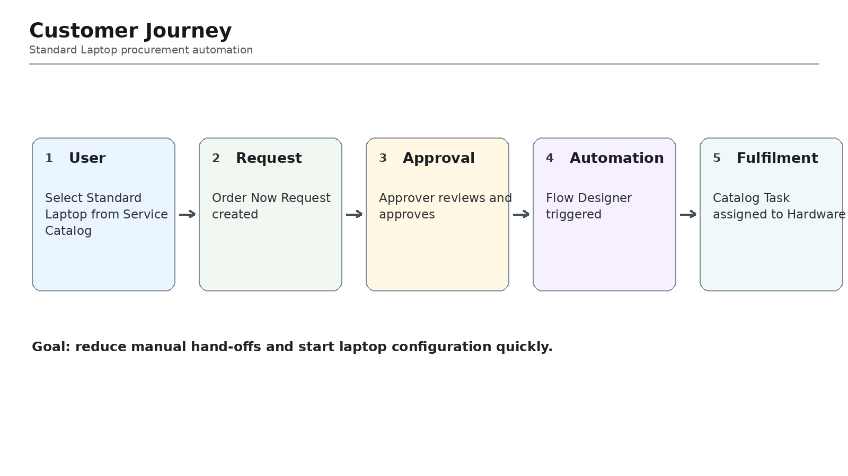
Journey Stages:
Stage | User / System Activity | Expected Outcome
1. Request | User selects Standard Laptop and submits Order Now. | Request is created.
2. Order | Service Catalog generates Request and Requested Item. | Request data is available.
3. Approval | Approver reviews and approves the request. | Approval status becomes Approved.
4. Automation | ServiceNow Flow Designer is triggered. | Automation starts.
5. Fulfilment | Catalog Task is created and assigned to Hardware. | Hardware team can configure laptop.
Project Goal:
Automate the standard laptop request path so that configuration work is generated consistently with minimal manual intervention.

